

**NEXON ECOMMARCE WEBSITE**

**SUBMITTED BY**

MUHAMMAD SARIM F2021105128

QURRAT UL AIN F2021105129

DAUD MUSTAFA F2021105159

MUHAMMAD AWAIS F2021105177

**SUBMITTED TO**

Ms. Taila Jabeen

**Subject**

DATABASE SYSTEMS

**Section**

Y-2

1. **Scope**
   1. **Overview:** Develop an Ecommerce website specifically designed for the sale and distribution of documentation-related products. The website will provide a platform for users to browse, search, purchase, and download various types of documentation, such as user manuals. The technical guides, instructional materials, and more.
   2. **Features:**

a. **User Registration and Authentication**:

Users can create accounts with their email addresses.

Users can log in using their credentials.

Password reset functionality will be implemented.

**b. Product Browsing:**

Users can browse products by categories.

Products will display their name, price, description, and production year.

Users can view detailed product information.

c**. Shopping Cart:**

Users can add products to their shopping cart.

Users can specify the quantity of each product.

Total cost calculation will be handled accurately.

**d. Checkout Process:**

Users can proceed to the checkout process.

Users can provide their delivery information (address, contact number).

Users can select a payment method.

**e. Order Placement:**

Orders will be created after successful checkout.

Orders will include the customer's information, purchased products, payment details, and delivery information.

**f. Order History:**

Users can view their order history.

Users can see the status of their orders.

**g. Customer Support:**

Users can contact customer support for assistance.

Users can provide feedback or raise concerns.

**Snapshots (user Interface)**

Home Webpage

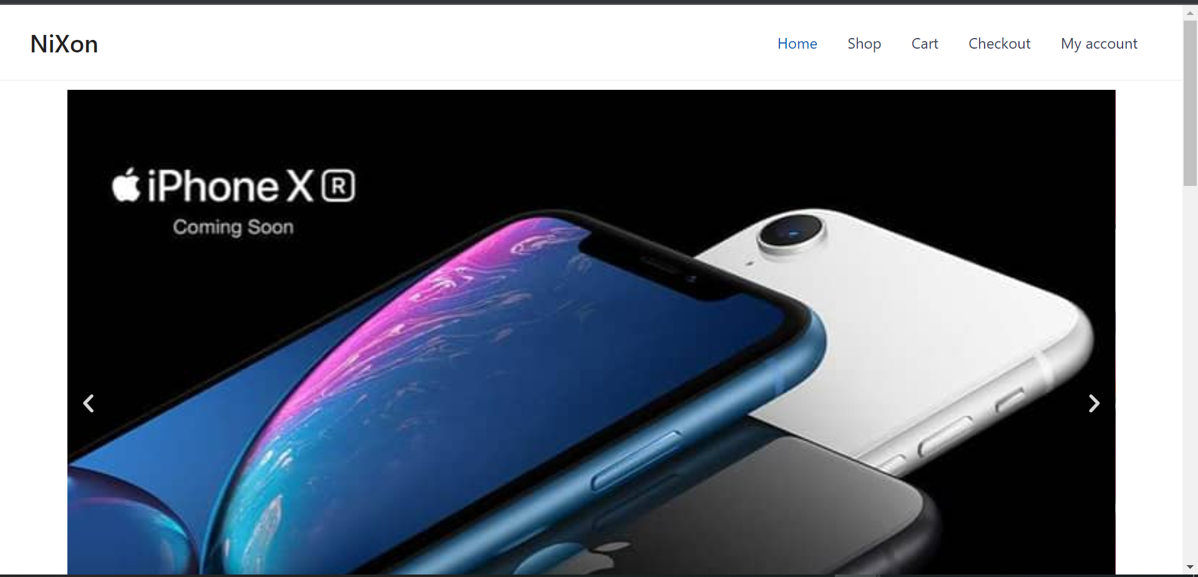

Shop page

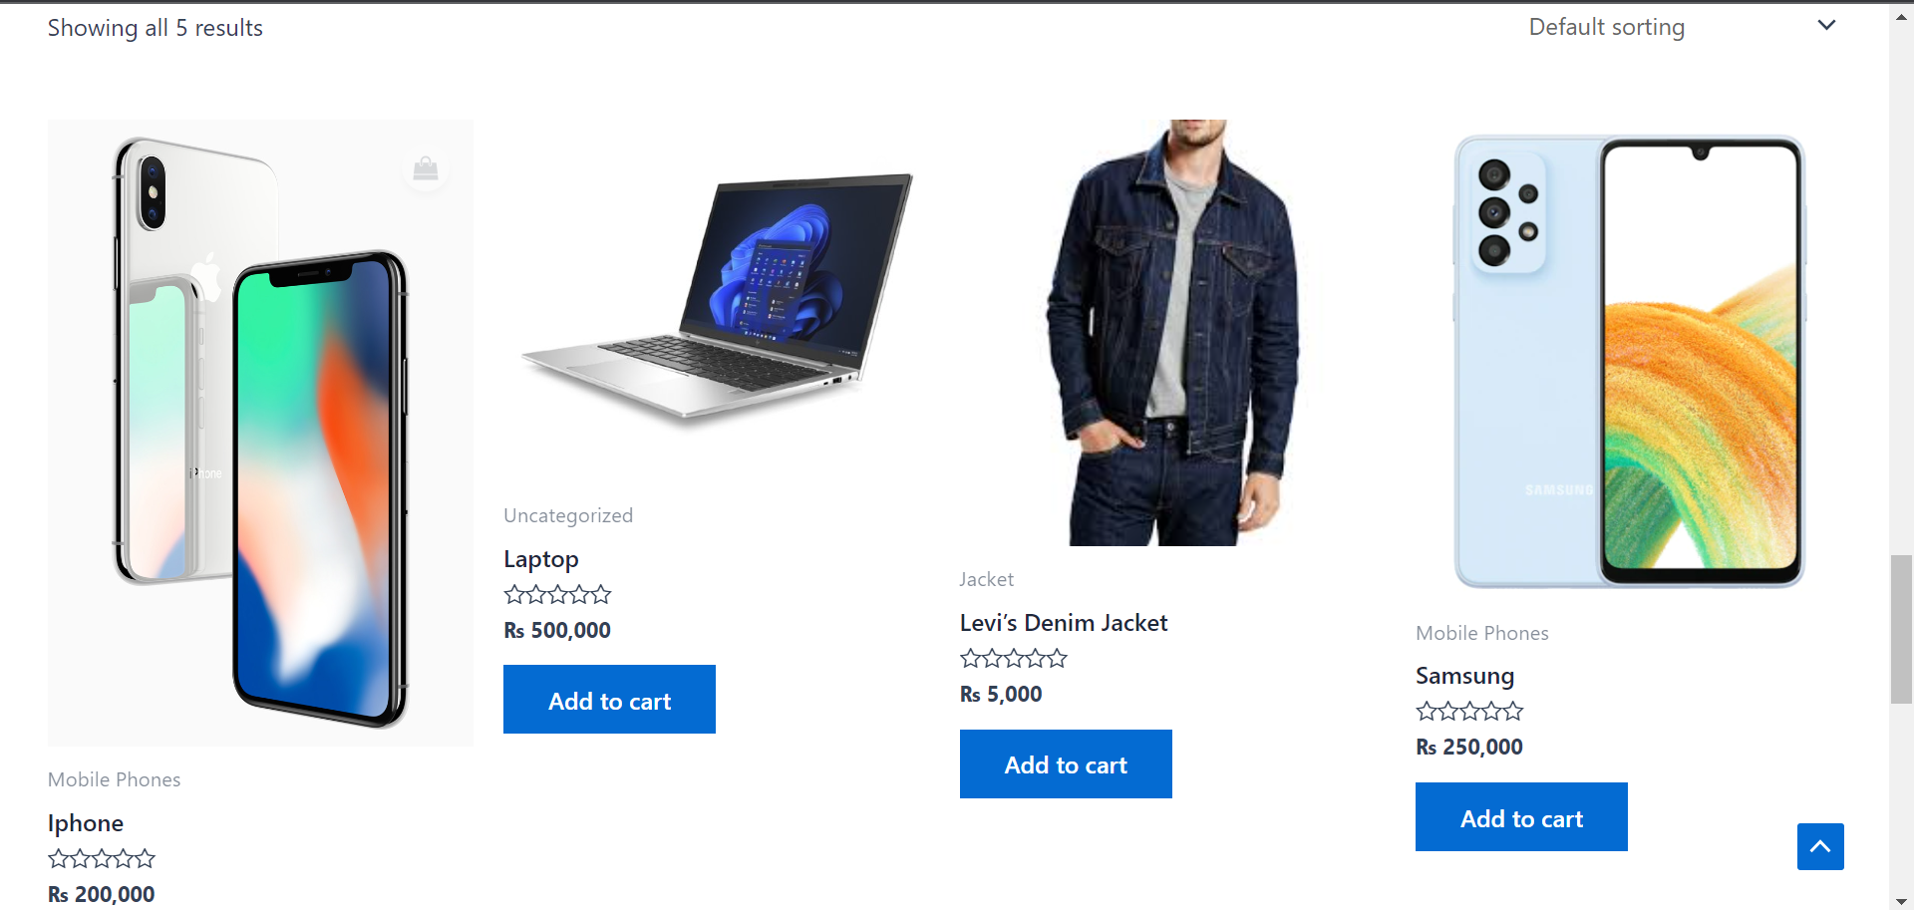

**Cart Page**

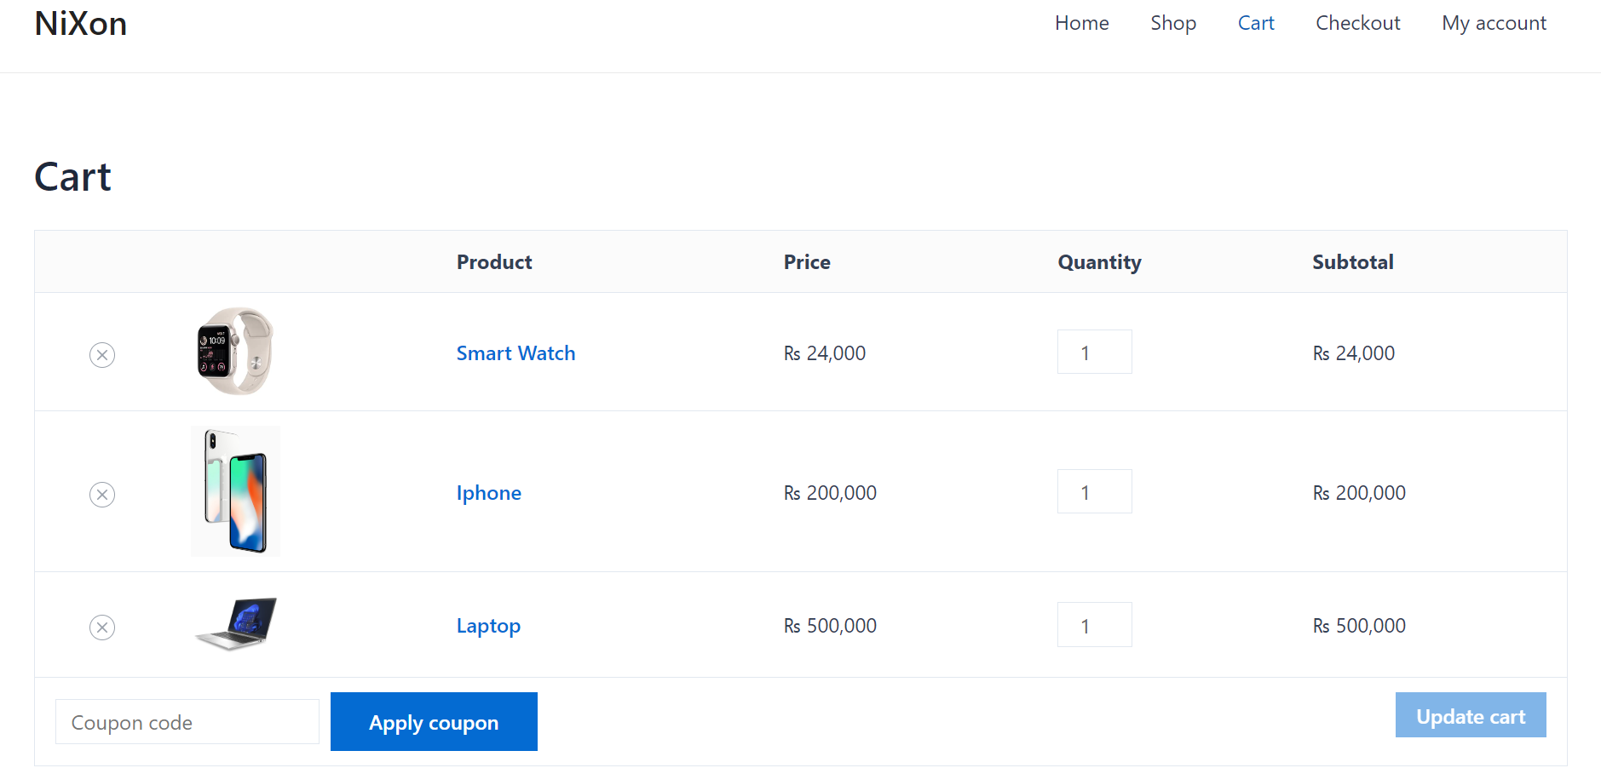

Check out

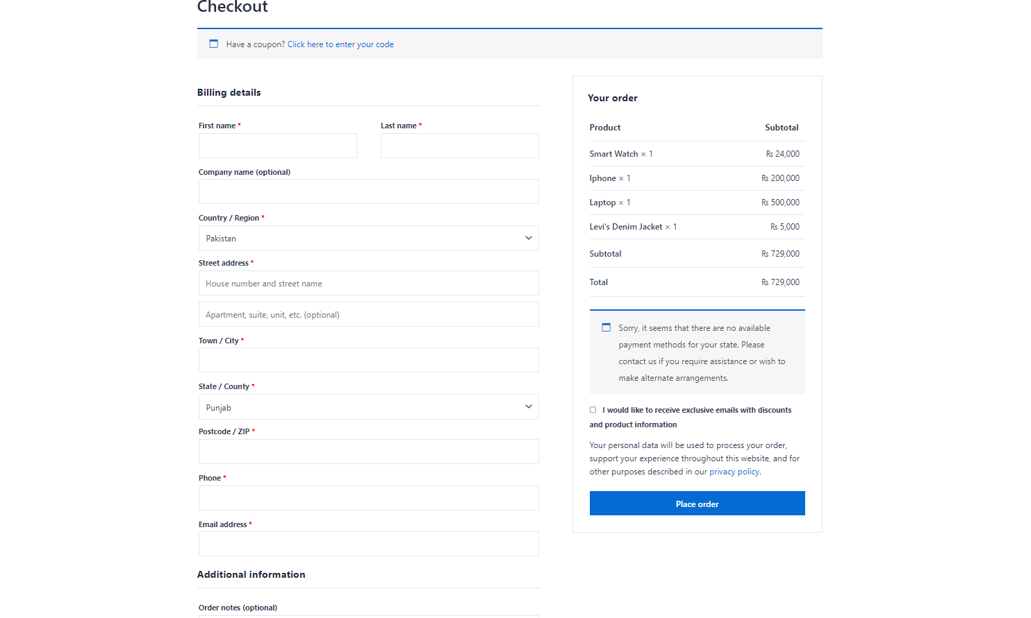

My Account Page

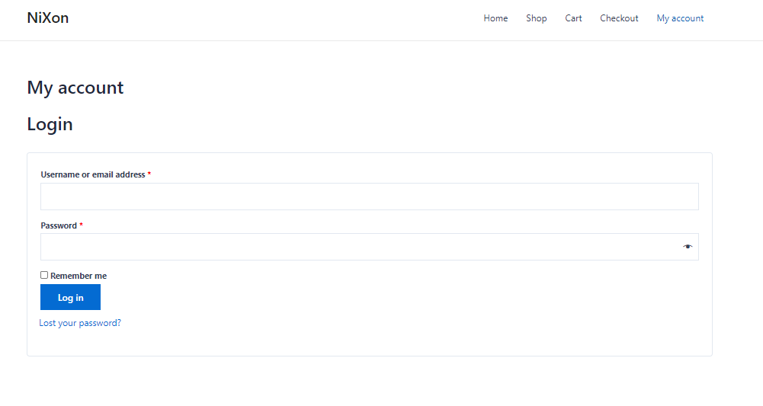

**Entities:**

* Entities represent real-world objects or concepts in a database.
* They can be tangible things like a person, a car, or a product, or intangible concepts like an order or a reservation.
* Each entity typically has a unique identifier called a primary key, which distinguishes it from other entities of the same type.
* Examples of entities: Customer, Employee, Product, Order.

**Attributes:**

* Attributes are characteristics or properties of entities.
* They describe the qualities or features of an entity.
* Each entity has one or more attributes that define its properties.
* Attributes can be simple or composite (composed of sub-attributes).
* They can be single-valued (containing one value) or multi-valued (containing multiple values).
* Examples of attributes: Name, Age, Address, Email.

**ENTITIES AND ATTRIBUTES IN E-COMMERCE WEB**

**Category Entity:**

Category_ID (Primary Key)

Category_Name

**Customer Entity:**

Customer_ID (Primary Key)

Customer_Email

Customer_FirstName

Customer_LastName

Address_House_Number

Address_Postal_Code

Address_Province

Address_City

**Customer_ContactNo Entity:**

Contact_Number

Customer_ID (Foreign Key referencing Customer(Customer_ID))

**Payment Entity:**

Payment_ID (Primary Key)

Customer_ID (Foreign Key referencing Customer(Customer_ID))

Payment_Date

Payment_Amount

Payment_Method

**Product Entity:**

Product_ID (Primary Key)

Product_Name

Product_Price

Product_Description

Production_Year

Category_ID (Foreign Key referencing Category(Category_ID))

Customer_ID (Foreign Key referencing Customer(Customer_ID))

**Cart Entity:**

Cart_ID (Primary Key)

Total_Cost

Product_ID (Foreign Key referencing Product(Product_ID))

Total_Product_Quantity

**Courier Entity:**

Courier_ID (Primary Key)

Courier_Name

Expected_Delivery_Date

Current_Location

Cart_ID (Foreign Key referencing Cart(Cart_ID))

Customer_ID (Foreign Key referencing Customer(Customer_ID))

**Courier_ContactNo Entity:**

Contact_No

Courier_ID (Foreign Key referencing Courier(Courier_ID))

DeliveryTo Entity:

Delivery_ID (Primary Key)

Delivery_Type

Customer_ID (Foreign Key referencing Customer(Customer_ID))

Courier_ID (Foreign Key referencing Courier(Courier_ID))

**E-R DIAGRAM**

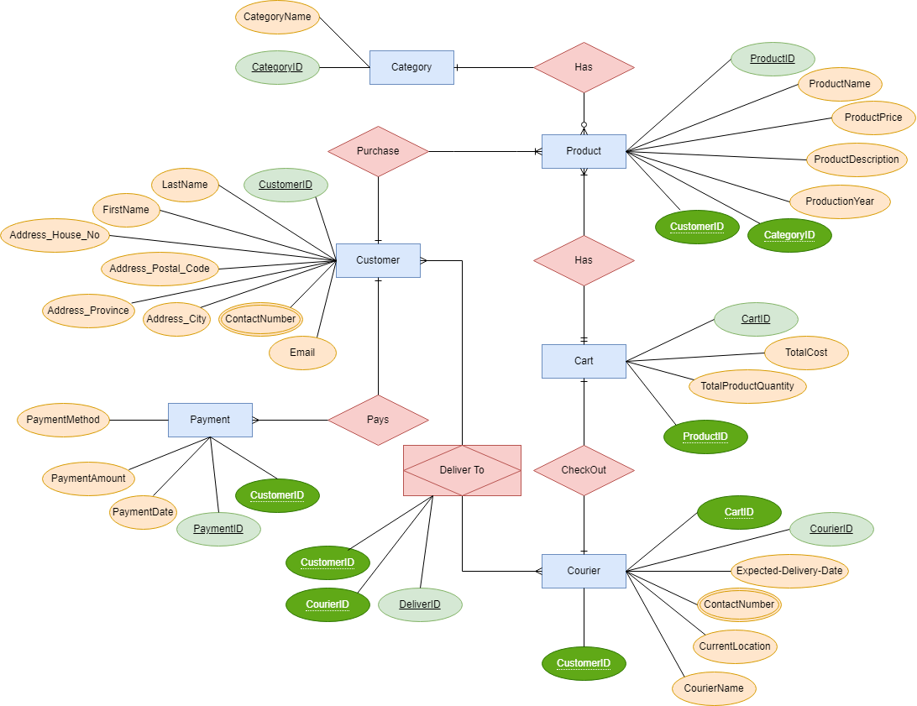

* **ER diagram stands for Entity-Relationship diagram.**
* It is a visual representation of the entities (objects or concepts) and their relationships in a database.
* The diagram consists of entities, attributes, and relationships.
* Entities represent real-world objects or concepts, such as a person, a product, or a customer.
* Attributes are properties or characteristics of entities, such as name, age, or price.
* Relationships define associations between entities, indicating how they are related to each other.
* Relationships can be one-to-one, one-to-many, or many-to-many.
* Cardinality and participation constraints can be represented in the diagram.
* Cardinality specifies the number of instances of one entity that can be associated with another entity.
* Participation constraints determine whether the participation of an entity in a relationship is mandatory (total) or optional (partial).
* The ER diagram serves as a blueprint for designing the database schema.
* It helps in identifying the primary keys, foreign keys, and the overall structure of the database.

**Relational Diagram**

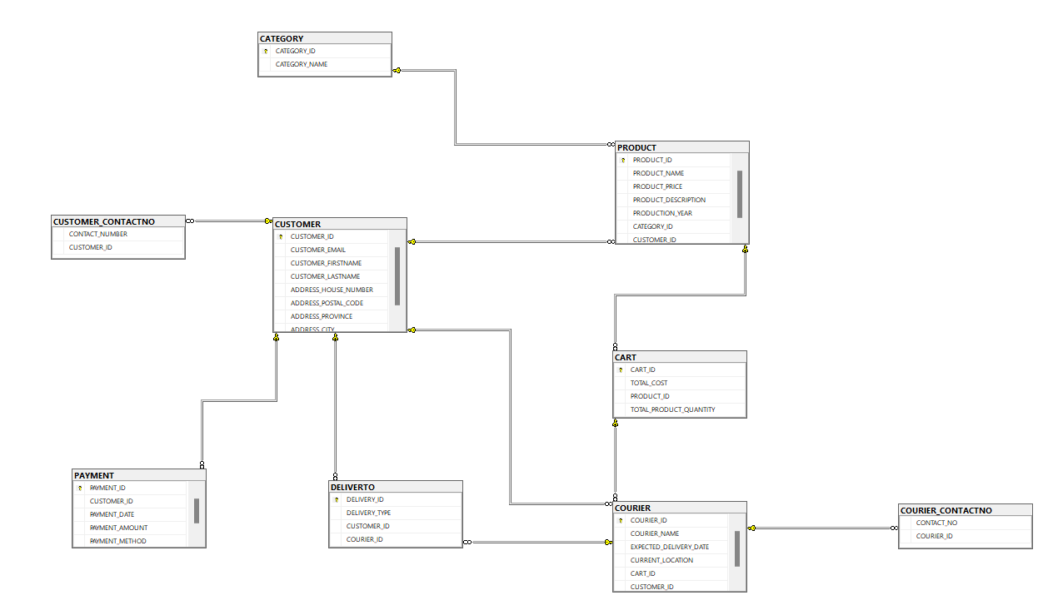

* **Relational diagram** represents the logical structure of a relational database.
* Tables are depicted as rectangles or boxes in the diagram.
* Each table represents an entity or concept in the database.
* The name of the table is usually displayed at the top of the rectangle.
* Attributes of a table are displayed inside the rectangle, usually as a list of columns.
* Primary keys are indicated in the diagram to uniquely identify each record in a table.
* Relationships between tables are represented by lines connecting them.
* The lines indicate the nature of the relationship, such as one-to-one, one-to-many, or many-to-many.
* Foreign keys, which establish the connections between tables, are depicted in the diagram.
* Cardinality and participation constraints can be specified in the diagram to indicate the nature of the relationships.
* The relational diagram provides an overview of the database structure and aids in understanding the relationships between tables and the attributes within them.
* It is used during the database design phase to plan and organize the database schema.

**SQL**

CREATE DATABASE ECOMMERCE

CREATE TABLE CATEGORY(

CATEGORY_ID INT PRIMARY KEY NOT NULL,

CATEGORY_NAME VARCHAR(50) NOT NULL

)

CREATE TABLE CUSTOMER(

CUSTOMER_ID INT PRIMARY KEY NOT NULL,

CUSTOMER_EMAIL VARCHAR(50) NOT NULL,

CUSTOMER_FIRSTNAME VARCHAR(50) NOT NULL,

CUSTOMER_LASTNAME VARCHAR(50),

ADDRESS_HOUSE_NUMBER VARCHAR(100) NOT NULL,

ADDRESS_POSTAL_CODE VARCHAR(50) NOT NULL,

ADDRESS_PROVINCE VARCHAR(30) NOT NULL,

ADDRESS_CITY VARCHAR(30) NOT NULL,

)

CREATE TABLE CUSTOMER_CONTACTNO(

CONTACT_NUMBER VARCHAR(20),

CUSTOMER_ID INT FOREIGN KEY(CUSTOMER_ID) REFERENCES CUSTOMER(CUSTOMER_ID)

)

CREATE TABLE PAYMENT(

PAYMENT_ID INT PRIMARY KEY NOT NULL,

CUSTOMER_ID INT FOREIGN KEY(CUSTOMER_ID) REFERENCES CUSTOMER(CUSTOMER_ID),

PAYMENT_DATE DATE NOT NULL,

PAYMENT_AMOUNT MONEY NOT NULL,

PAYMENT_METHOD VARCHAR(20) NOT NULL

)

CREATE TABLE PRODUCT(

PRODUCT_ID INT PRIMARY KEY NOT NULL,

PRODUCT_NAME VARCHAR(50) NOT NULL,

PRODUCT_PRICE MONEY CHECK(PRODUCT_PRICE>0) NOT NULL,

PRODUCT_DESCRIPTION VARCHAR(100),

PRODUCTION_YEAR DATE,

CATEGORY_ID INT FOREIGN KEY(CATEGORY_ID) REFERENCES CATEGORY(CATEGORY_ID),

CUSTOMER_ID INT FOREIGN KEY(CUSTOMER_ID) REFERENCES CUSTOMER(CUSTOMER_ID)

)

CREATE TABLE CART(

CART_ID INT PRIMARY KEY NOT NULL,

TOTAL_COST MONEY NOT NULL,

PRODUCT_ID INT FOREIGN KEY(PRODUCT_ID) REFERENCES PRODUCT(PRODUCT_ID),

TOTAL_PRODUCT_QUANTITY INT CHECK(TOTAL_PRODUCT_QUANTITY>0) NOT NULL

)

CREATE TABLE COURIER(

COURIER_ID INT PRIMARY KEY NOT NULL,

COURIER_NAME VARCHAR(50) NOT NULL,

EXPECTED_DELIVERY_DATE DATE NOT NULL,

CURRENT_LOCATION VARCHAR(50) NOT NULL,

CART_ID INT FOREIGN KEY(CART_ID) REFERENCES CART(CART_ID),

CUSTOMER_ID INT FOREIGN KEY(CUSTOMER_ID) REFERENCES CUSTOMER(CUSTOMER_ID)

)

CREATE TABLE COURIER_CONTACTNO(

CONTACT_NO VARCHAR(20),

COURIER_ID INT FOREIGN KEY(COURIER_ID) REFERENCES COURIER(COURIER_ID)

)

CREATE TABLE DELIVERTO(

DELIVERY_ID INT PRIMARY KEY NOT NULL,

DELIVERY_TYPE VARCHAR(50) NOT NULL,

CUSTOMER_ID INT FOREIGN KEY(CUSTOMER_ID) REFERENCES CUSTOMER(CUSTOMER_ID),

COURIER_ID INT FOREIGN KEY(COURIER_ID) REFERENCES COURIER(COURIER_ID)

)

**INSERT DATA**

INSERT INTO CATEGORY(CATEGORY_ID,CATEGORY_NAME)

VALUES

(1, 'Electronics'),

(2, 'Clothing'),

(3, 'Home & Kitchen'),

(4, 'Books'),

(5, 'Sports & Outdoors'),

(6, 'Beauty'),

(7, 'Toys & Games'),

(8, 'Automotive'),

(9, 'Health & Personal Care'),

(10, 'Jewelry')

INSERT INTO CUSTOMER (CUSTOMER_ID, CUSTOMER_EMAIL, CUSTOMER_FIRSTNAME, CUSTOMER_LASTNAME, ADDRESS_HOUSE_NUMBER, ADDRESS_POSTAL_CODE, ADDRESS_PROVINCE, ADDRESS_CITY)

VALUES

(1, 'john@example.com', 'John', 'Doe', '123 Main S', '12345', 'California', 'Los Angeles'),

(2, 'jane@example.com', 'Jane', 'Smith', '456 Oak', '67890', 'New York', 'New York City'),

(3, 'mike@example.com', 'Mike', 'Johnson', '789 Elm', '54321', 'Texas', 'Houston'),

(4, 'amy@example.com', 'Amy', 'Williams', '987 Pine', '13579', 'Florida', 'Miami'),

(5, 'david@example.com', 'David', 'Brown', '321 Cedar', '86420', 'Illinois', 'Chicago'),

(6, 'emily@example.com', 'Emily', 'Taylor', '555 Maple', '24680', 'Washington', 'Seattle'),

(7, 'alex@example.com', 'Alex', 'Davis', '222 Walnut', '97531', 'Massachusetts', 'Boston'),

(8, 'lisa@example.com', 'Lisa', 'Martinez', '444 Oak', '68390', 'Colorado', 'Denver'),

(9, 'sam@example.com', 'Sam', 'Anderson', '777 Elm', '19567', 'Arizona', 'Phoenix'),

(10, 'sarah@example.com', 'Sarah', 'Garcia', '888 Pine', '43785', 'Georgia', 'Atlanta'),

(11, 'mark@example.com', 'Mark', 'Wilson', '111 Oak', '24680', 'California', 'San Francisco'),

(12, 'laura@example.com', 'Laura', 'Thompson', '222 Elm', '13579', 'New York', 'Albany'),

(13, 'chris@example.com', 'Chris', 'Walker', '333 Maple', '86420', 'Texas', 'Dallas'),

(14, 'jennifer@example.com', 'Jennifer', 'Harris', '444 Pine', '97531', 'Florida', 'Orlando'),

(15, 'kevin@example.com', 'Kevin', 'Lewis', '555 Cedar', '68390', 'Illinois', 'Springfield'),

(16, 'sophia@example.com', 'Sophia', 'Clark', '666 Walnut', '19567', 'Washington', 'Spokane'),

(17, 'ryan@example.com', 'Ryan', 'Young', '777 Oak', '43785', 'Massachusetts', 'Worcester'),

(18, 'natalie@example.com', 'Natalie', 'Hall', '888 Elm', '36987', 'Colorado', 'Colorado Springs'),

(19, 'peter@example.com', 'Peter', 'Allen', '999 Pine', '58291', 'Arizona', 'Tucson'),

(20, 'olivia@example.com', 'Olivia', 'Turner', '101 Maple', '71936', 'Georgia', 'Savannah'),

(21, 'robert@example.com', 'Robert', 'Parker', '111 Walnu', '49572', 'California', 'San Diego'),

(22, 'amanda@example.com', 'Amanda', 'Phillips', '222 Elm', '72648', 'New York', 'Buffalo'),

(23, 'michael@example.com', 'Michael', 'Roberts', '333 Cedar', '28573', 'Texas', 'Austin'),

(24, 'jessica@example.com', 'Jessica', 'Scott', '444 Pine', '61749', 'Florida', 'Tampa'),

(25, 'andrew@example.com', 'Andrew', 'Adams', '555 Oak', '39482', 'Illinois', 'Peoria'),

(26, 'grace@example.com', 'Grace', 'Walker', '666 Elm', '95836', 'Washington', 'Bellevue'),

(27, 'daniel@example.com', 'Daniel', 'Morris', '777 Maple', '26194', 'Massachusetts', 'Cambridge'),

(28, 'samantha@example.com', 'Samantha', 'Baker', '888 Walnut', '67934', 'Colorado', 'Boulder'),

(29, 'jonathan@example.com', 'Jonathan', 'Mitchell', '999 Pine', '17485', 'Arizona', 'Mesa'),

(30, 'hannah@example.com', 'Hannah', 'Hayes', '101 Cedar', '62739', 'Georgia', 'Augusta'),

(31, 'matthew@example.com', 'Matthew', 'Ward', '111 Oak', '53642', 'California', 'San Jose'),

(32, 'victoria@example.com', 'Victoria', 'Rogers', '222 Elm', '94638', 'New York', 'Rochester'),

(33, 'ethan@example.com', 'Ethan', 'Sullivan', '333 Maple', '28194', 'Texas', 'Houston'),

(34, 'lily@example.com', 'Lily', 'Cooper', '444 Pine', '76391', 'Florida', 'Miami'),

(35, 'benjamin@example.com', 'Benjamin', 'Turner', '555 Cedar', '16285', 'Illinois', 'Chicago'),

(36, 'audrey@example.com', 'Audrey', 'Perry', '666 Walnut', '87462', 'Washington', 'Seattle'),

(37, 'nathan@example.com', 'Nathan', 'Kelly', '777 Oak', '53624', 'Massachusetts', 'Boston'),

(38, 'claire@example.com', 'Claire', 'Barnes', '888 Elm', '27394', 'Colorado', 'Denver'),

(39, 'jacob@example.com', 'Jacob', 'Wood', '999 Pine', '74938', 'Arizona', 'Phoenix'),

(40, 'zoey@example.com', 'Zoey', 'Turner', '101 Maple', '47593', 'Georgia', 'Atlanta'),

(41, 'sebastian@example.com', 'Sebastian', 'Morgan', '111 Walnut', '94627', 'California', 'San Francisco'),

(42, 'sean@example.com', 'Sean', 'Turner', '444 Pine', '97462', 'Florida', 'Orlando'),

(43, 'amelia@example.com', 'Amelia', 'Gray', '555 Oak', '52639', 'Illinois', 'Springfield'),

(44, 'gavin@example.com', 'Gavin', 'Hudson', '666 Elm', '27635', 'Washington', 'Spokane'),

(45, 'isabella@example.com', 'Isabella', 'Collins', '777 Maple', '62539', 'Massachusetts', 'Worcester'),

(46, 'henry@example.com', 'Henry', 'Bryant', '888 Walnut', '94637', 'Colorado', 'Colorado Springs'),

(47, 'violet@example.com', 'Violet', 'Parker', '999 Pine', '47582', 'Arizona', 'Tucson'),

(48, 'caleb@example.com', 'Caleb', 'Murphy', '101 Cedar', '83746', 'Georgia', 'Savannah'),

(49, 'lillian@example.com', 'Lillian', 'Harris', '111 Oak', '36482', 'California', 'San Diego'),

(50, 'gabriel@example.com', 'Gabriel', 'Turner', '222 Elm', '59273', 'New York', 'Albany');

INSERT INTO CUSTOMER_CONTACTNO (CONTACT_NUMBER, CUSTOMER_ID)

VALUES

('+92-300-1234567', 1),

('+92-321-9876543', 2),

('+92-333-5555555', 3),

('+92-345-8888888', 4),

('+92-300-9999999', 5),

('+92-300-1234666', 1),

('+92-321-9876577', 2),

('+92-333-5555444', 3),

('+92-345-8866888', 4),

('+92-300-9119999', 5),

('+92-300-1210567', 1),

('+92-321-9878543', 2),

('+92-333-5578955', 3),

('+92-345-8811888', 4),

('+92-300-9990999', 5);

INSERT INTO PAYMENT (PAYMENT_ID, CUSTOMER_ID, PAYMENT_DATE, PAYMENT_AMOUNT, PAYMENT_METHOD) VALUES

(1, 50, '2023-05-01', 50.00, 'Credit Card'),

(2, 49, '2023-05-02', 20.00, 'PayPal'),

(3, 48, '2023-05-03', 15.99, 'Credit Card'),

(4, 47, '2023-05-04', 10.50, 'PayPal'),

(5, 46, '2023-05-05', 100.00, 'Credit Card'),

(6, 45, '2023-05-06', 75.50, 'Credit Card'),

(7, 44, '2023-05-07', 40.00, 'PayPal'),

(8, 43, '2023-05-08', 60.25, 'Credit Card'),

(9, 42, '2023-05-09', 12.99, 'PayPal'),

(10, 41, '2023-05-10', 200.00, 'Credit Card'),

(11, 39, '2023-05-11', 30.00, 'Credit Card'),

(12, 38, '2023-05-12', 18.75, 'PayPal'),

(13, 37, '2023-05-13', 100.99, 'Credit Card'),

(14, 36, '2023-05-14', 75.00, 'PayPal'),

(15, 35, '2023-05-15', 80.50, 'Credit Card'),

(16, 34, '2023-05-16', 45.00, 'PayPal'),

(17, 33, '2023-05-17', 150.25, 'Credit Card'),

(18, 32, '2023-05-18', 25.99, 'PayPal'),

(19, 31, '2023-05-19', 70.00, 'Credit Card'),

(20, 30, '2023-05-20', 90.50, 'Credit Card'),

(21, 29, '2023-05-21', 60.00, 'PayPal'),

(22, 28, '2023-05-22', 42.75, 'Credit Card'),

(23, 27, '2023-05-23', 80.99, 'PayPal'),

(24, 26, '2023-05-24', 55.00, 'Credit Card'),

(25, 25, '2023-05-25', 175.25, 'PayPal'),

(26, 24, '2023-05-26', 35.99, 'Credit Card'),

(27, 23, '2023-05-27', 90.00, 'PayPal'),

(28, 22, '2023-05-28', 120.50, 'Credit Card'),

(29, 21, '2023-05-29', 15.00, 'Credit Card'),

(30, 20, '2023-05-30', 50.75, 'PayPal');

INSERT INTO PRODUCT(PRODUCT_ID, PRODUCT_NAME, PRODUCT_PRICE, PRODUCT_DESCRIPTION, PRODUCTION_YEAR, CATEGORY_ID) VALUES

(1, 'iPhone 12', 999.00, 'Flagship smartphone from Apple','2008-11-11', 1),

(2, 'Samsung Galaxy S21', 899.00, 'High-end Android smartphone from Samsung','2021-09-09' , 2),

(3, 'Nike Air Max', 129.00, 'Popular athletic shoes with cushioning and style', '2021-1-17', 2),

(4, 'Levi''s Jeans', 79.00, 'Classic denim jeans from Levi''s', '2005-11-18', 2),

(5, 'KitchenAid Mixer', 349.00, 'Versatile kitchen mixer for baking and cooking', '2021-11-10', 3),

(6, 'Sony 65" 4K TV', 1499.00, 'Ultra-high-definition smart TV with stunning visuals', '2021-1-30', 1),

(7, 'Adidas Ultraboost', 169.00, 'Comfortable and stylish running shoes from Adidas', '2022-1-12', 2),

(8, 'Amazon Echo Dot', 49.99, 'Smart speaker with Alexa voice assistant', '2022-09-1', 3),

(9, 'Harry Potter and the Sorcerer''s Stone', 14.99, 'First book in the Harry Potter series by J.K. Rowling', '1997-03-22', 4),

(10, 'Wilson Tennis Racquet', 89.99, 'Professional-grade racquet for tennis players', '2022-10-21', 5),

(11, 'MacBook Pro', 1999.00, 'Powerful and sleek laptop for professionals', '2022-02-18', 5),

(12, 'Calvin Klein T-Shirt', 29.99, 'Classic and comfortable t-shirt from Calvin Klein','2018-10-11', 2),

(13, 'Cuisinart Blender', 79.00, 'High-performance blender for smoothies and more', '2000-2-12', 3),

(14, 'The Great Gatsby', 9.99, 'Classic novel by F. Scott Fitzgerald', '1995-10-21', 4),

(15, 'Yoga Mat', 19.99, 'Non-slip mat for yoga and fitness exercises', '2018-11-10', 5),

(16, 'Samsung 55" QLED TV', 1299.00, 'High-quality smart TV with vibrant colors', '2022-10-11', 1),

(17, 'Puma Sneakers', 89.99, 'Stylish and comfortable sneakers from Puma', '2019-11-11', 2),

(18, 'Instant Pot', 99.99, 'Multi-function electric pressure cooker and kitchen appliance','2020-1-29', 3),

(19, 'To Kill a Mockingbird', 12.99, 'Classic novel by Harper Lee', '1960-08-11', 5),

(20, 'Basketball', 24.99, 'Official size and weight basketball','1888-09-11', 5),

(21, 'Apple Watch Series 6', 399.00, 'Advanced smartwatch with health monitoring features', '2016-07-21', 1),

(22, 'Ralph Lauren Polo Shirt', 49.99, 'Stylish and comfortable polo shirt','2019-07-21' , 2),

(23, 'Keurig Coffee Maker', 129.00, 'Single-serve coffee maker with multiple brew sizes','2015-06-1', 3),

(24, 'The Lord of the Rings Trilogy', 29.99, 'Epic fantasy book series by J.R.R. Tolkien', '2016-05-21', 4),

(25, 'Outdoor Camping Tent', 79.99, 'Spacious tent for outdoor camping adventures','2016-07-22', 5),

(26, 'Google Pixel 5', 799.00, 'Android smartphone with exceptional camera capabilities','2015-07-21', 1),

(27, 'Under Armour Leggings', 59.99, 'Comfortable leggings for workouts and active wear','2014-11-21', 2),

(28, 'NutriBullet Blender', 69.00, 'Compact blender for making smoothies and shakes','2016-08-21', 3),

(29, '1984 by George Orwell', 11.99, 'Dystopian novel by George Orwell', '1994-09-21', 4),

(30, 'Dumbbell Set', 49.99, 'Adjustable dumbbells for strength training', '1991-07-16', 5),

(31, 'Sony PlayStation 5', 499.00, 'Next-generation gaming console from Sony','2007-12-21', 1),

(32, 'Tommy Hilfiger Hoodie', 79.99, 'Comfortable and stylish hoodie from Tommy Hilfiger', '2021-12-1', 2),

(33, 'Hamilton Beach Toaster', 39.99, 'Four-slice toaster with multiple settings','2016-02-22', 3),

(34, 'Ray-Ban Sunglasses', 129.99, 'Classic sunglasses with UV protection','2021-02-21', 2),

(35, 'Crock-Pot Slow Cooker', 49.99, 'Programmable slow cooker for convenient cooking', '1996-02-09', 3),

(36, 'The Catcher in the Rye', 8.99, 'Coming-of-age novel by J.D. Salinger','1959-07-21', 4),

(37, 'Soccer Ball', 14.99, 'Official size and weight soccer ball','1919-07-05', 5),

(38, 'Canon EOS Rebel T7', 599.00, 'Entry-level DSLR camera for photography enthusiasts', '1899-05-21', 1),

(39, 'Nike Air Force 1', 109.00, 'Iconic sneakers with timeless design', '2022-09-21', 2),

(40, 'Instant Camera', 79.99, 'Compact camera for instant photo printing','2002-02-28', 3),

(41, 'Amazon Echo Dot (4th Gen)', 49.99, 'Smart speaker with Alexa voice assistant','2016-07-10', 3),

(42, 'Fitbit Charge 4', 149.99, 'Fitness tracker with built-in GPS and heart rate monitoring','2007-07-07', 1),

(43, 'Adidas Stan Smith', 79.99, 'Iconic sneakers with clean and classic design', '2000-10-20', 2),

(44, 'Amazon Kindle Paperwhite', 129.99, 'Waterproof e-reader with built-in adjustable light','1898-11-12', 3),

(45, 'The Hobbit', 10.99, 'Fantasy novel by J.R.R. Tolkien', '1937-07-28', 4),

(46, 'Mountain Bike', 499.99, 'Durable and versatile bike for off-road adventures', '2010-05-29', 5),

(47, 'Bose QuietComfort 35 II', 299.00, 'Wireless noise-canceling headphones','1977-07-1', 1),

(48, 'Michael Kors Watch', 199.99, 'Elegant and stylish wristwatch', '1986-04-04', 2),

(49, 'Ninja Foodi Grill', 229.00, 'Indoor grill with multiple cooking functions','1998-03-10', 3),

(50, 'The Alchemist', 14.99, 'Bestselling novel by Paulo Coelho', '1998-02-02', 4),

(51, 'Resistance Bands Set', 29.99, 'Versatile workout equipment for strength training', '2001-01-01', 5);

INSERT INTO CART (CART_ID, TOTAL_COST, PRODUCT_ID, TOTAL_PRODUCT_QUANTITY)

VALUES (1, 25.99, 51, 2),(2, 39.99, 12, 1),(3, 15.50, 3, 3),(4, 12.00, 4, 4),(5, 9.99, 22, 2),

(6, 49.99, 9, 1),(7, 29.99, 51, 2),(8, 19.99, 50, 3),(9, 7.99, 49, 1),(10, 14.50, 48, 2),

(11, 9.99, 47, 1),(12, 35.99, 46, 3),(13, 12.99, 45, 1),(14, 9.99, 44, 2),(15, 25.99, 43, 1),

(16, 19.99, 42, 1),(17, 39.99, 41, 2),(18, 14.50, 40, 1),(19, 9.99, 39, 2),(20, 49.99, 38, 1),

(21, 29.99, 37, 3),(22, 19.99, 36, 1),(23, 7.99, 35, 2),(24, 14.50, 34, 1),(25, 9.99, 33, 1),

(26, 35.99, 32, 2),(27, 12.99, 31, 1);

INSERT INTO COURIER (COURIER_ID, COURIER_NAME, EXPECTED_DELIVERY_DATE, CURRENT_LOCATION, CART_ID, CUSTOMER_ID) VALUES

(1, 'DHL', '2023-06-10', 'New York', 1, 1),

(2, 'FedEx', '2023-06-12', 'Chicago', 2, 2),

(3, 'UPS', '2023-06-08', 'Los Angeles', 3, 3),

(4, 'USPS', '2023-06-09', 'Miami', 4, 4),

(5, 'TNT', '2023-06-11', 'Dallas', 5, 5),

(6, 'UPS', '2023-06-10', 'Seattle', 6, 6),

(7, 'DHL', '2023-06-11', 'San Francisco', 7, 7),

(8, 'FedEx', '2023-06-13', 'Houston', 8, 8),

(9, 'USPS', '2023-06-09', 'Boston', 9, 9),

(10, 'TNT', '2023-06-14', 'Atlanta', 10, 10),

(11, 'DHL', '2023-06-10', 'Chicago', 11, 11),

(12, 'UPS', '2023-06-12', 'New York', 12, 12),

(13, 'FedEx', '2023-06-15', 'Los Angeles', 13, 13),

(14, 'USPS', '2023-06-09', 'Seattle', 14, 14),

(15, 'TNT', '2023-06-11', 'San Francisco', 15, 15),

(16, 'UPS', '2023-06-12', 'Houston', 16, 16),

(17, 'DHL', '2023-06-13', 'Miami', 17, 17),

(18, 'FedEx', '2023-06-14', 'Boston', 18, 18),

(19, 'USPS', '2023-06-09', 'Atlanta', 19, 19),

(20, 'TNT', '2023-06-10', 'Chicago', 20, 20),

(21, 'DHL', '2023-06-11', 'New York', 21, 21),

(22, 'UPS', '2023-06-15', 'Los Angeles', 22, 22),

(23, 'FedEx', '2023-06-09', 'Seattle', 23, 23),

(24, 'USPS', '2023-06-12', 'San Francisco', 24, 24),

(25, 'TNT', '2023-06-13', 'Houston', 25, 25),

(26, 'UPS', '2023-06-14', 'Boston', 26, 26),

(27, 'DHL', '2023-06-09', 'Atlanta', 27, 27);

INSERT INTO COURIER_CONTACTNO (CONTACT_NO, COURIER_ID)

VALUES

('0300-1234567', 1),

('0312-9876543', 2),

('0321-4567890', 3),

('0333-8765432', 4),

('0345-2345678', 5),

('0355-6789012', 6),

('0366-3456789', 7),

('0377-8901234', 8),

('0388-4567890', 9),

('0399-0987654', 10),

('0300-1111111', 11),

('0312-2222222', 12),

('0321-3333333', 13),

('0333-4444444', 14),

('0345-5555555', 15),

('0355-6666666', 16),

('0366-7777777', 17),

('0377-8888888', 18),

('0388-9999999', 19),

('0399-0000000', 20);

INSERT INTO COURIER_CONTACTNO (CONTACT_NO, COURIER_ID)

VALUES

('0300-1234566', 1),

('0312-9876544', 2),

('0321-4567899', 3),

('0333-8765433', 4),

('0345-2345677', 5),

('0355-6789011', 6),

('0366-3456788', 7),

('0377-8901233', 8),

('0388-4567899', 9),

('0399-0987655', 10),

('0300-0111110', 11),

('0312-0222220', 12),

('0321-0333330', 13),

('0333-0444440', 14),

('0345-0555550', 15),

('0355-0666660', 16),

('0366-0777770', 17),

('0377-0888880', 18),

('0388-0999990', 19),

('0399-1000001', 20);

INSERT INTO DELIVERTO (DELIVERY_ID, DELIVERY_TYPE, CUSTOMER_ID, COURIER_ID) VALUES

(1, 'Standard', 1, 1),

(2, 'Express', 2, 2),

(3, 'Standard', 3, 3),

(4, 'Express', 4, 4),

(5, 'Standard', 5, 5),

(6, 'Standard', 6, 6),

(7, 'Express', 7, 7),

(8, 'Standard', 8, 8),

(9, 'Express', 9, 9),

(10, 'Standard', 10, 10),

(11, 'Standard', 11, 11),

(12, 'Express', 12, 12),

(13, 'Standard', 13, 13),

(14, 'Express', 14, 14),

(15, 'Standard', 15, 15),

(16, 'Standard', 16, 16),

(17, 'Express', 17, 17),

(18, 'Standard', 18, 18),

(19, 'Express', 19, 19),

(20, 'Standard', 20, 20),

(21, 'Standard', 21, 21),

(22, 'Express', 22, 22),

(23, 'Standard', 23, 23),

(24, 'Express', 24, 24),

(25, 'Standard', 25, 25),

(26, 'Standard', 26, 26),

(27, 'Express', 27, 27);

SQL Queries

**ALTER QURERY**

TRUNCATE TABLE CATEGORY

ALTER TABLE CATEGORY ADD CATEGORY_DATE INT DEFAULT 0;

a

**UPDATE QURERY**

UPDATE DELIVERTO SET DELIVERY_TYPE='BY ROAD' WHERE DELIVERY_ID=26

SELECT * FROM DELIVERTO WHERE DELIVERY_ID = 26 AND DELIVERY_TYPE = 'BY ROAD'

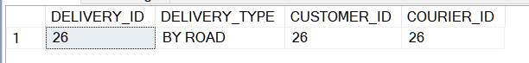

UPDATE CUSTOMER SET CUSTOMER_EMAIL='gabriel@raybal.com' WHERE CUSTOMER_ID=50

SELECT * FROM CUSTOMER WHERE CUSTOMER_EMAIL='gabriel@raybal.com';



DELETE FROM DELIVERTO WHERE DELIVERY_ID=27

**OPERATORS**

SELECT CUSTOMER_FIRSTNAME FROM CUSTOMER WHERE CUSTOMER_FIRSTNAME LIKE '%a%' OR CUSTOMER_FIRSTNAME LIKE 'D%'

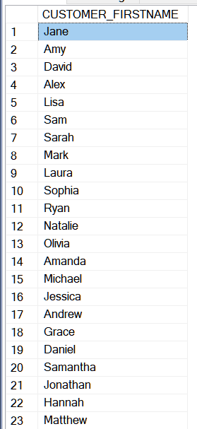

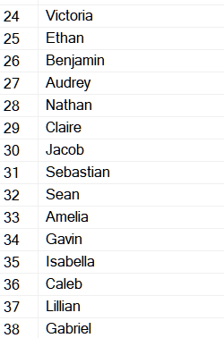

SELECT CUSTOMER_ID,CUSTOMER_FIRSTNAME,CUSTOMER_LASTNAME FROM CUSTOMER

WHERE CUSTOMER_FIRSTNAME='John' AND CUSTOMER_LASTNAME ='Doe'

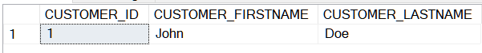

**AGGREGATE FUNCTION**

SELECT MAX(PAYMENT_AMOUNT) AS MAXIMUM_AMOUNT,MIN(PAYMENT_AMOUNT) AS MINIMUM_AMOUNT,AVG(PAYMENT_AMOUNT) AS AVERAGE_PAYMENT

FROM PAYMENT

WHERE PAYMENT_METHOD LIKE 'P%'

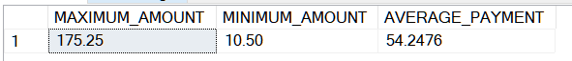

SELECT COUNT(*) AS NUMBER FROM CUSTOMER WHERE CUSTOMER_EMAIL LIKE '%raybal%'

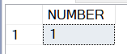

**GROUP BY**

SELECT PAYMENT_METHOD,AVG(PAYMENT_AMOUNT) AS AVERAGE

FROM PAYMENT

GROUP BY(PAYMENT_METHOD)

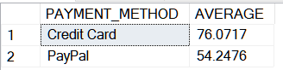

SELECT COUNT(*) AS TOTAL,COURIER_ID

FROM COURIER_CONTACTNO

GROUP BY(COURIER_ID)

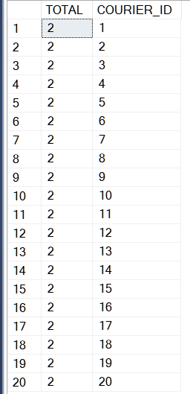

**/*HAVING - Used to filter out aggregate functions*/**

SELECT CATEGORY_ID,AVG(PRODUCT_PRICE) AS AVERAGE

FROM PRODUCT

GROUP BY(CATEGORY_ID)

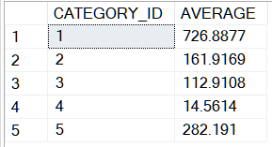

SELECT CATEGORY_ID,AVG(PRODUCT_PRICE) AS AVERAGE

FROM PRODUCT

GROUP BY(CATEGORY_ID)

HAVING AVG(PRODUCT_PRICE)>700.00



**/*ORDER BY*/**

SELECT PRODUCT_NAME,PRODUCT_PRICE

FROM PRODUCT

ORDER BY PRODUCT_PRICE ASC

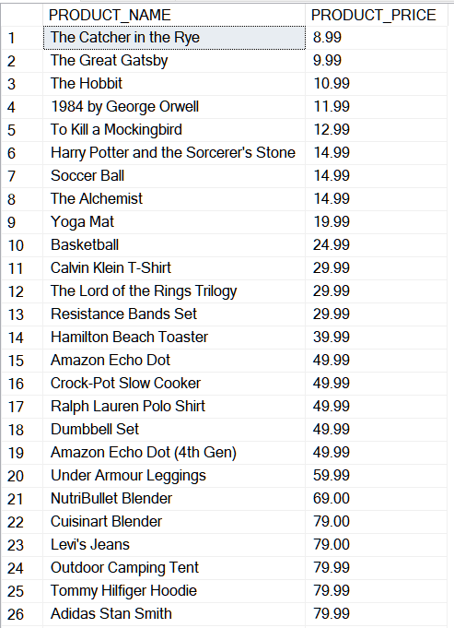

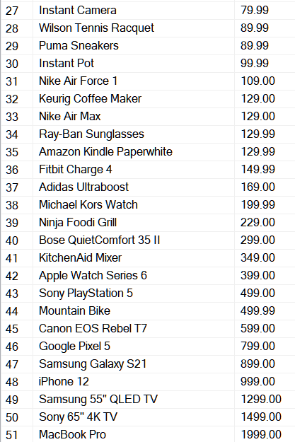

SELECT PRODUCT_NAME,PRODUCT_PRICE

FROM PRODUCT

ORDER BY PRODUCT_PRICE DESC

**JOINS**

SELECT D.DELIVERY_TYPE,C.CUSTOMER_FIRSTNAME

FROM DELIVERTO D

INNER JOIN

CUSTOMER C

ON C.CUSTOMER_ID = D.CUSTOMER_ID

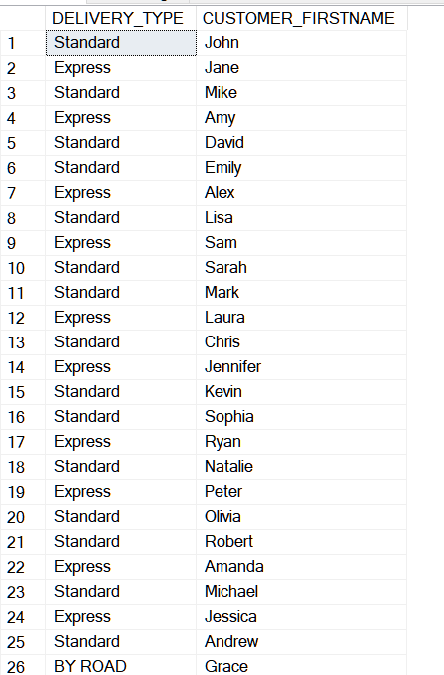

SELECT C.CUSTOMER_FIRSTNAME,C.CUSTOMER_LASTNAME,P.PAYMENT_ID

FROM PAYMENT P

LEFT JOIN

CUSTOMER C

ON P.CUSTOMER_ID = C.CUSTOMER_ID

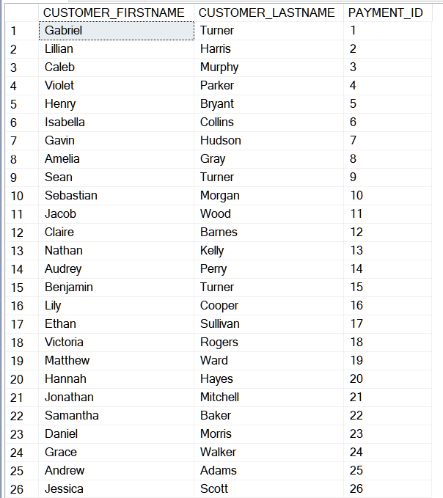

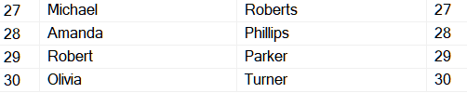

SELECT C.CUSTOMER_FIRSTNAME,C.CUSTOMER_LASTNAME,P.PAYMENT_ID

FROM PAYMENT P

RIGHT JOIN

CUSTOMER C

ON P.CUSTOMER_ID = C.CUSTOMER_ID

